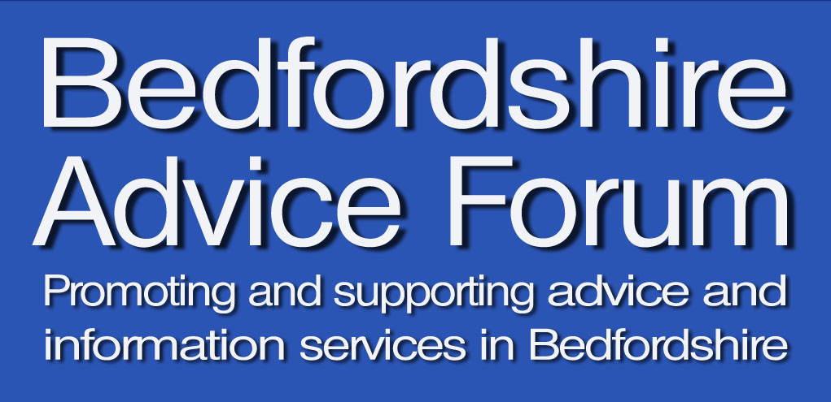

THE HISTORY OF BAF

The table below gives a short history of BAF.

Year | Membership area | Members | Chair | Income | Main activities
1997/98 | North Bedfordshire | No record | Helen Voce  (Bedford CAB) | No record | Bedford Advice Forum formed at meeting in July 1997  No records for 1997/98
1998/99 | North Bedfordshire | No record | Helen Voce  (Bedford CAB) | No record | No records for 1998/99
1999/00 | North Bedfordshire |  | Helen Voce  (Bedford CAB) | £573 | Forum meetings (4) - including AGM  Training Sub-Group meetings  Training courses (3)  Development of Bedfordshire Advice Directory
2000/01 | North Bedfordshire | No record | Helen Voce  (Bedford CAB) | £635 | Forum meetings (4) – Including AGM  Training Sub-Group meetings  Training courses (6)  Launch of first Bedfordshire Advice Directory (2000)  Developing links with CLS Partnership  Collation of benefit gain figure from BAF members
2001/02 | North Bedfordshire & Mid Bedfordshire | 42 | Helen Voce  (Bedford CAB) and then, from October 2001, temporary chairs elected for each forum meeting | No record (closing balance was £1,790) | Forum meetings (4) – Including AGM  Training Sub-Group meetings  Extension of BAF membership to Mid Beds agencies  Training courses (7)  Information sessions (2)  Input into local bid for Financial Literacy Project  Appointment of part-time administrator for BAF (through Lottery funding for BHL)

Year | Membership area | Members | Chair | Income | Main activities
2002/03 | North Bedfordshire & Mid Bedfordshire | No record | Diane Wynne-Powell (CVS) | No record (closing balance was £4,122.43) | Forum meetings (4)  Training sub-group meetings  Training courses (6)  2nd edition of Advice Directory (2003)  Links with Mid and North Beds CLS Partnership  Launch of BAF-STEP project (including research into local training and development needs)
2003/04 | North Bedfordshire & Mid Bedfordshire | 54 | Diane Wynne-Powell (CVS) | £77,000 | Forum meetings (4)  Training-sub-group meetings (6)  Links with Take the Credit benefit campaign  BAF-STEP project (including 26 training courses, consultancy support to 12 BAF members and NVQ support programme for 10 candidates)  Links with Mid and North Beds CLSP  LSC LID project (2 training courses)
2004/05 | North Bedfordshire & Mid Bedfordshire | 52 | Linda Wood  (Bedford CAB) | No record | Forum meetings (4) + AGM  Formation of BAF Steering Group (replacing training sub-group)  Steering Group meetings (6)  Development of BAF policies on Equal Opportunities, Health and Safety and Environment  Links with Mid and North Beds CLS Partnership  BAF NVQ programme  Training courses (5)  3rd edition of Advice Directory (2005)
2005/06 | North Bedfordshire & Mid Bedfordshire | 56 | David Verney  (Age Concern) | £740 | Forum meetings (4) + AGM  Steering Group meetings (4)  Training courses (4)  Completion of BAF NVQ programme  Survey of BAF members for Debt Advice in Bedfordshire  Discussions on future of BAF – A positive future for BAF  Links with research into Benefits Advice in Bedfordshire

Year | Area covered | Members | Chair | Income | Main activities
2006/07 | North Bedfordshire & Mid Bedfordshire | 52 | David Verney  (Age Concern) | £1,875 | Forum meetings (4) + AGM  Steering Group meetings (6)  Training courses (4)  Development of BAF Strategy (2006-2009)  Discussions on forming a trading company for BAF  Amendment sheet (2006) for Advice Directory distributed  Work on developing a standardised referral policy for BAF agencies  Input into discussion on potential Advice Plus funding bid
2007/08 | North Bedfordshire, Mid Bedfordshire & South Bedfordshire | 65 | David Verney  (Age Concern) | £2,745 | Change of name to Bedfordshire Advice Forum  Extension of BAF membership into South Bedfordshire  Further implementation of BAF Strategy  Launch of BAF’s trading company - Advice Bedfordshire CIC  Forum meetings (4) + AGM  Steering Group meetings (4)  Training courses (3)  Support for development of Q-cas
2008/09 | North Bedfordshire, Mid Bedfordshire & South Bedfordshire | 42 | Wendy Anderson-Welsh (BREC) | £6,715 | Forum meetings (reduced to 3 a year) + AGM  Introduction of BAF membership fees  Steering Group meetings (reduced to 3 a year)  Advice Bedfordshire started trading (surplus of £653)  Training courses (5)  Launch of BAF website  BAF joined VoluntaryWorks – and accessed Capacitybuilders funding to enable the development of links with local strategic forums
2009/10 | Bedford Borough & Central Bedfordshire | 42 | Wendy Anderson-Welsh (BREC) | £19,386 | Forum meetings (3) + AGM  Steering Group meetings (3)  2 training programmes (7 courses) – Advising in the Economic Crisis - funded by Bedfordshire County Council  Development of further links with strategic forums using Capacitybuilders funding from VoluntaryWorks  Funding from Bedfordshire County Council – for development of online Bedfordshire Advice Directory, and research into links between advice agencies and children’s centres  Advice Bedfordshire (surplus = £352)

Year | Area covered | Members | Chair | Income | Main activities
2010/11 | Bedford Borough & Central Bedfordshire | 44 | Wendy Anderson-Welsh (BREC) | £13,822 | Forum meetings (3) + AGM  Steering Group meetings (3)  Development of Advice Strategies in Bedford Borough and Central Bedfordshire  Training courses (7) – including 6 courses funded by the Bedfordshire Redundancy Support Group on Advising in the Economic Crisis  Further funding from Capacitybuilders through VoluntaryWorks enabling continued links with local strategic forums  Pilot launch of new Bedfordshire Benefits Network  Advice Bedfordshire (surplus = £22)
2011/12 | Bedford Borough & Central Bedfordshire | 42 | Lorraine Gunther (Bedford CAB) | £1,070 | Forum meetings (3) + AGM  Steering Group meetings (3)  2nd pilot meeting of Bedfordshire Benefits Network  Development of Work Plan for BAF (2011/12)  Implementation of Advice Strategy for Bedford Borough and facilitation of new Advice Management Group (3 meetings held)  Agreement of Advice Strategy for Central Bedfordshire  BAF was a partner in successful VoluntaryWorks bid for Transforming Local Infrastructure project  Further support for local Q-cas training programme  Training courses (2)  Advice Bedfordshire (surplus = £286)
2012/13 | Bedford Borough & Central Bedfordshire | 44 | Lorraine Gunther (Bedford CAB) | £17,823 | Forum meetings (3) + AGM  Steering Group meetings (3)  Meetings of Bedfordshire Benefits Network (3)  Development of Work Plan for BAF (2012/13)  Facilitation of Advice Planning Board (Central Bedfordshire) – 2 meetings held  Funding from Bedford Borough Partnership Board to facilitate Advice Management Group (3 meetings), organise consultation with advice service users, and develop links with Bedford Jobs Hub  Welfare Reform awareness sessions (2) and training courses (4)  Lunchtime talk on insolvency  Support for VoluntaryWorks Transforming Local Infrastructure project  Project to develop closer links between advice agencies and local solicitors in Bedford Borough  Advice Bedfordshire (surplus = £569)  Initial input into development of local bids to Advice Service Transition Fund

Year | Area covered | Members | Chair | Income | Main activities
2013/14 | Bedford Borough & Central Bedfordshire | 45 | Fiona McLeod  (Money Advice at St Andrews) | £14,147 | Forum meetings (3) + AGM  Steering Group meetings (3) + 2 extra meetings to discuss future of BAF  Meetings of Bedfordshire Benefits Network (2) with funding from Bedford Borough Partnership Board  Development of Work Plan for BAF (2013/14)  Funding from Central Bedfordshire Council for facilitation of Advice Planning Board – 4 meetings held  Funding from VoluntaryWorks Transforming Local Infrastructure project for development of 4 accredited advice skills training courses  Further work on solicitors project (in Central Bedfordshire)  Developing links with new ASTF projects – Bedford Advice Network and AdviceCentral  Launch of Welfare Reform webpage on BAF website  Advice Bedfordshire (surplus = £350)

